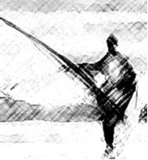
DSC WindSurfer 11 March 2012

Sail Main ____________________________________
Rips/grommets/controls

Main Sheet Boom

____________________________________

____________________________________

Lines; ____________________________________
Foot & Mast safety

_________________________________

Stbd Hull _________________________________
Bow / Stern chips / Drain / fittings

Skeg Spare Skeg ?_________________________________

Mast ____________________________________
Fittings / float / step / saddle /

Comments:

